SYLVAN RUSH
Key Screenshots — Figure Set
Enchanted Forest Endless Runner · Unity 6

Source footage | game_screen record_new (Google Vids → exported MP4)
Resolution | 1920 × 1080 · 30 fps · H.264
Duration | 3 min 43 s
Frames extracted | 7 figures, cropped to the Game view (1080 × 884)
Captured | 11 November 2026

Each figure below is a full-resolution frame pulled straight from the recording and cropped to the in-game viewport, so nothing from the Unity chrome is visible except in Figure 1, where the surrounding editor is the point.

Figure 1
Report caption 3.1
Section 3.3 (Project Folder Structure) / 4.2 (Scene Setup) · Unity Editor interface showing the Scene view, Hierarchy (Player, TrackManager, ObstacleSpawner) and the Project Assets folder.
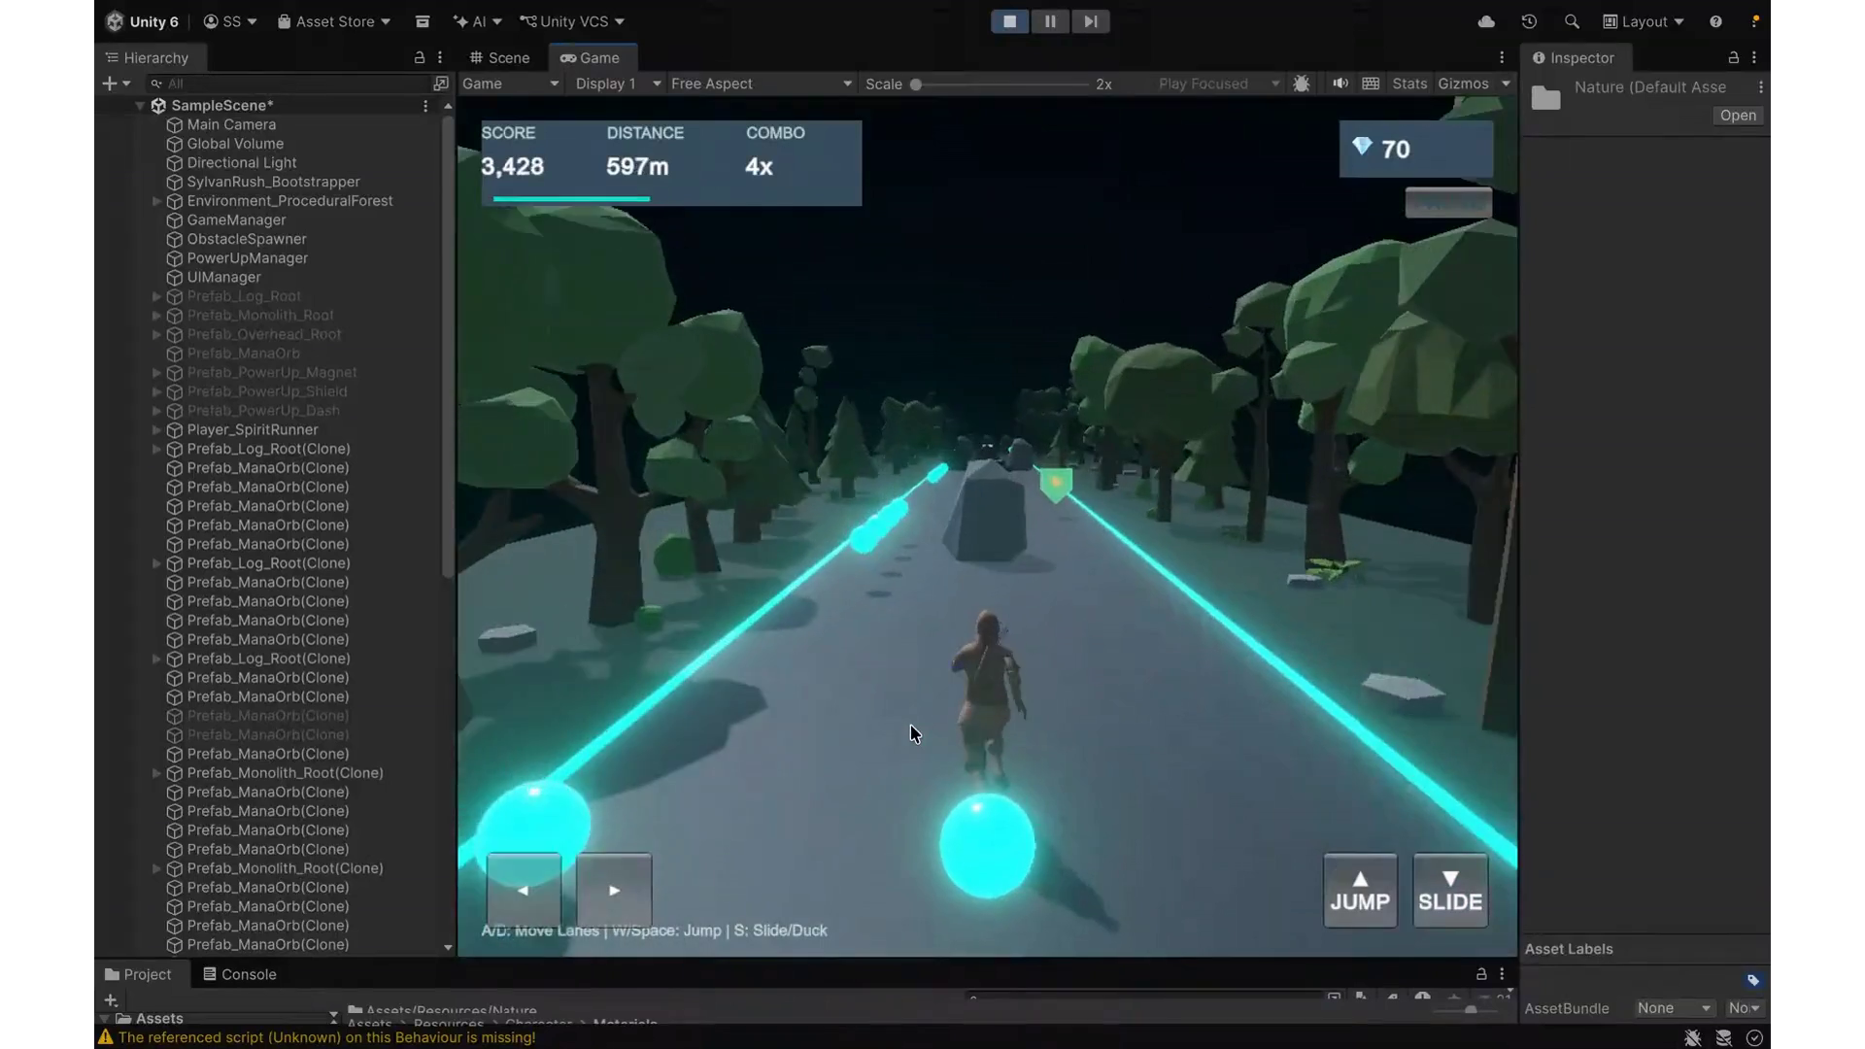
Figure 3.1: Unity 6 Editor workspace, Scene hierarchy, and project asset architecture.
Source note: Captured at 00:45 — the only clean full-Editor frame. Hierarchy clearly lists Main Camera, Global Volume, Directional Light, SylvanRush_Bootstrapper, Environment_ProceduralForest, GameManager, ObstacleSpawner, PowerUpManager, UIManager and the Prefab_* pooled instances. Toolbar confirms Unity 6.

Figure 2
Report caption 5.1
Section 5.2 & 5.3 (Jumping & Obstacles) · Player character mid-air, leaping cleanly over the Woodland Tree Stump.
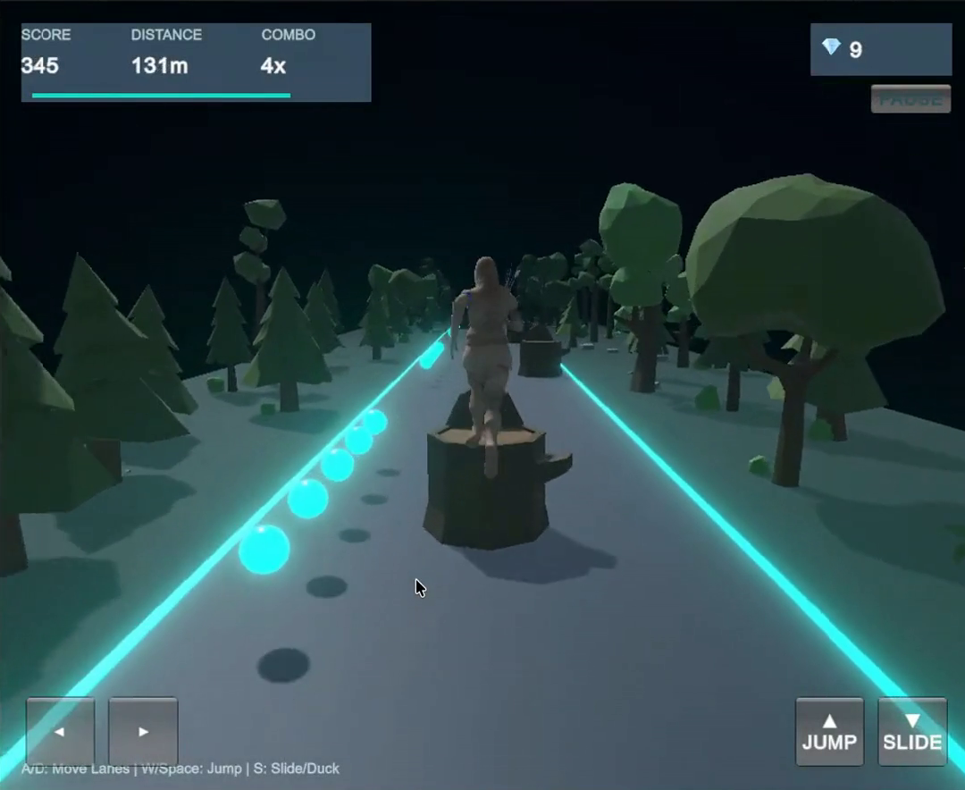
Figure 5.1: Calibrated jump physics (15.5 vertical impulse, 3.33 m apex) clearing the Woodland Tree Stump.
Source note: Captured at 00:30.4 — character is fully airborne directly above the stump, shadow separated below. Best jump-over-obstacle frame in the clip; HUD shows 345 pts / 131 m / 4x combo.

Figure 3
Report caption 5.2
Section 5.5 (Collectibles and Power-Ups) · Player running with the Bark Shield active while pulling Mana Orbs toward the lane.
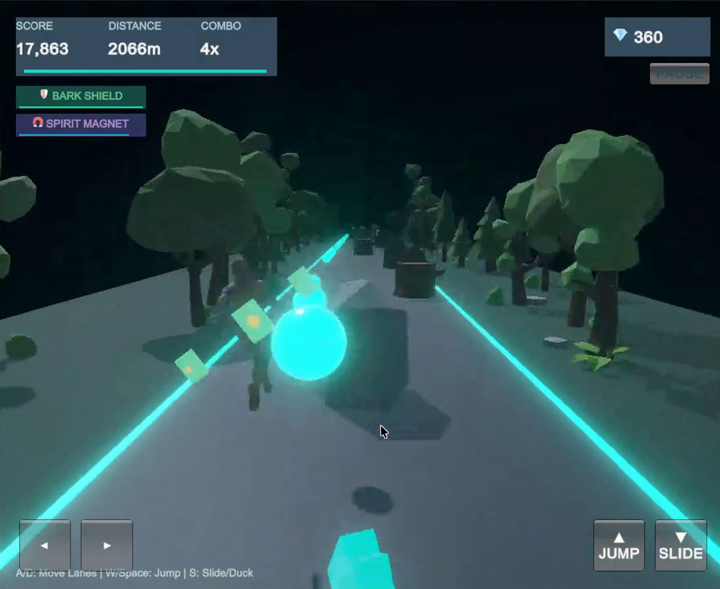
Figure 5.2: Active 3D Spirit Blessing showing 3 orbiting emerald-gold shields and HUD duration gauge.
Source note: Captured at 03:21. Both power-up chips are lit in the HUD (BARK SHIELD + SPIRIT MAGNET) and the orb vacuum effect is visible on the left as orbs stream toward the player. NOTE: the orbiting shields read more as an orb/jet glow than three distinct emerald-gold rings in this footage — if the report needs three clearly separated orbiting shields, a fresh capture of the Bark Shield pickup would be stronger.

Figure 4
Report caption 6.1
Section 6.1 & 6.2 (Forest Environment & Lighting) · Full perspective shot of the 3-lane woodland track showing fog, directional lighting and the glowing lane rails.
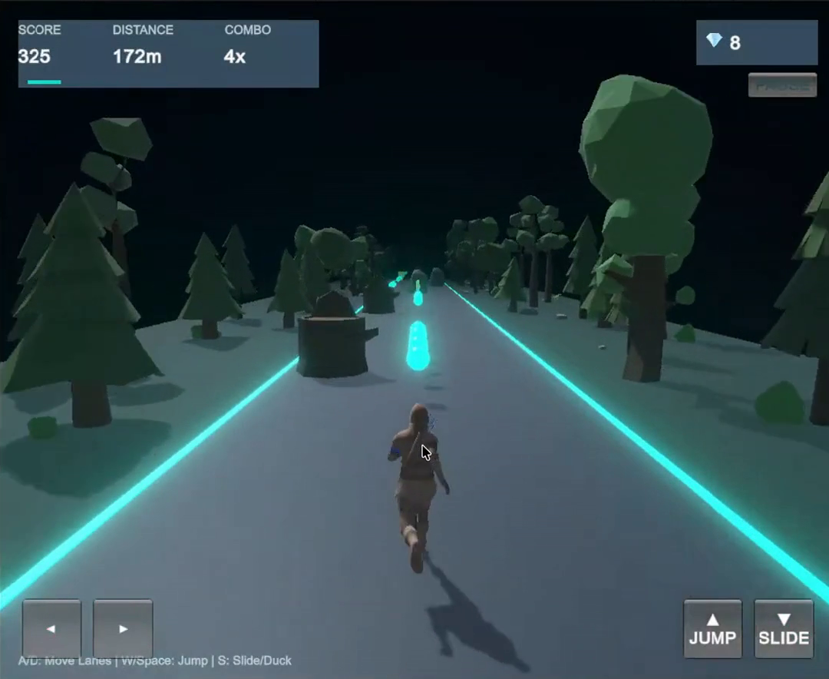
Figure 6.1: Procedural track pathway with URP atmospheric fog and bioluminescent forest flora.
Source note: Captured at 00:56. Strongest single frame for environment art: deep-black sky, teal lane rails converging to the vanishing point, low-poly conifers and broadleaf trees, distant obstacles silhouetted in the fog.

Figure 5
Report caption 7.1
Section 7.2 (User Interface – Title Screen) · The pre-game Title Card displaying Controls, Obstacles, Spirit Blessings and the Start button.
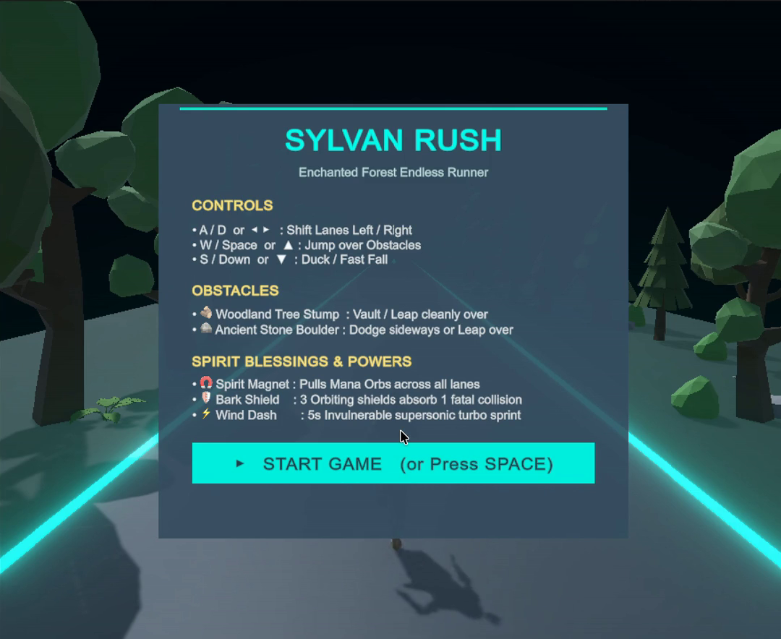
Figure 7.1: Pre-game Title Card UI rendered via native OnGUI detailing controls and hazard mechanics.
Source note: Captured at 02:21. The card is fully readable: SYLVAN RUSH / Enchanted Forest Endless Runner, all three control mappings, both obstacle types, all three Spirit Blessings, and the START GAME (or Press SPACE) button.

Figure 6
Report caption 7.2
Section 7.2 (User Interface – HUD) · Active gameplay view highlighting the top HUD (Score, Distance, real-time Combo Decay Gauge, Orbs) and the on-screen D-Pad.
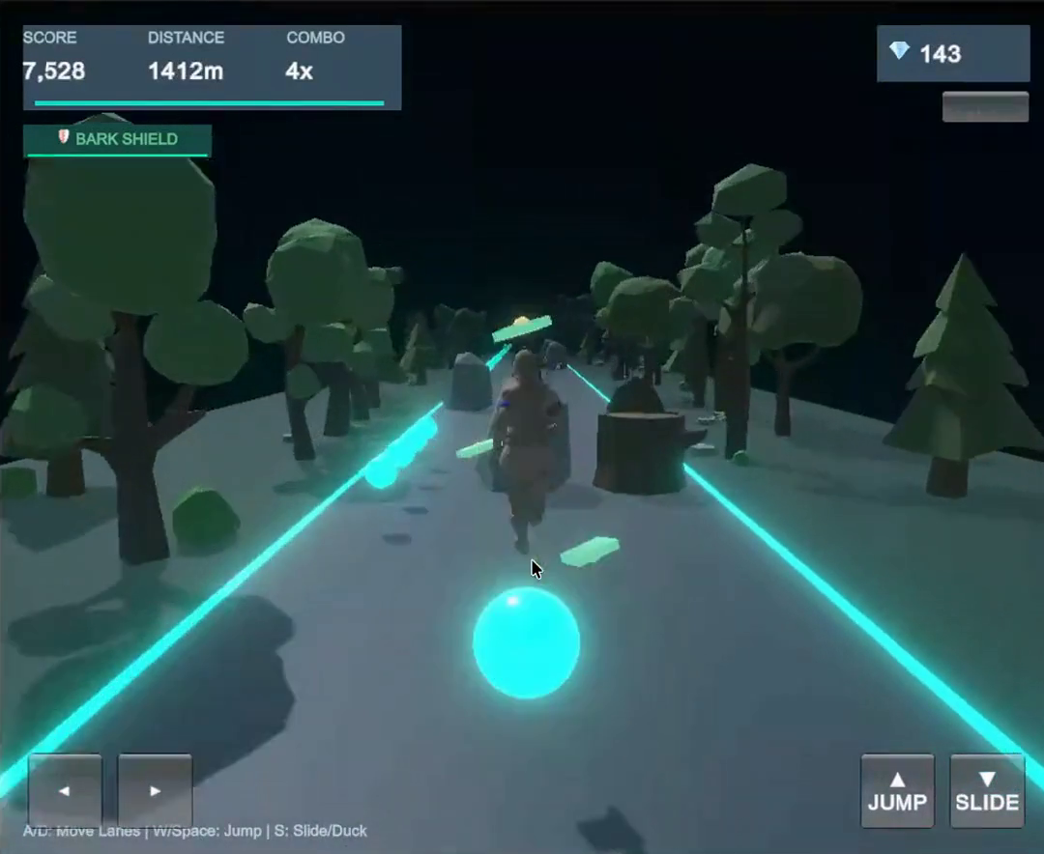
Figure 7.2: In-game HUD displaying live score combo multiplier decay, distance, and touch controls.
Source note: Captured at 01:31. Clean HUD read: SCORE 7,312 · DISTANCE 1,412 m · COMBO 4x with the decaying teal combo bar underneath, orb counter 143 top-right, power-up chip, JUMP/SLIDE buttons and the keyboard hint strip.

Figure 7
Report caption 8.1
Section 8.0 (Gameplay Flow & Game-State) · The Run Complete / Game Over overlay showing final score, meters run, mana orbs gathered and personal best records.
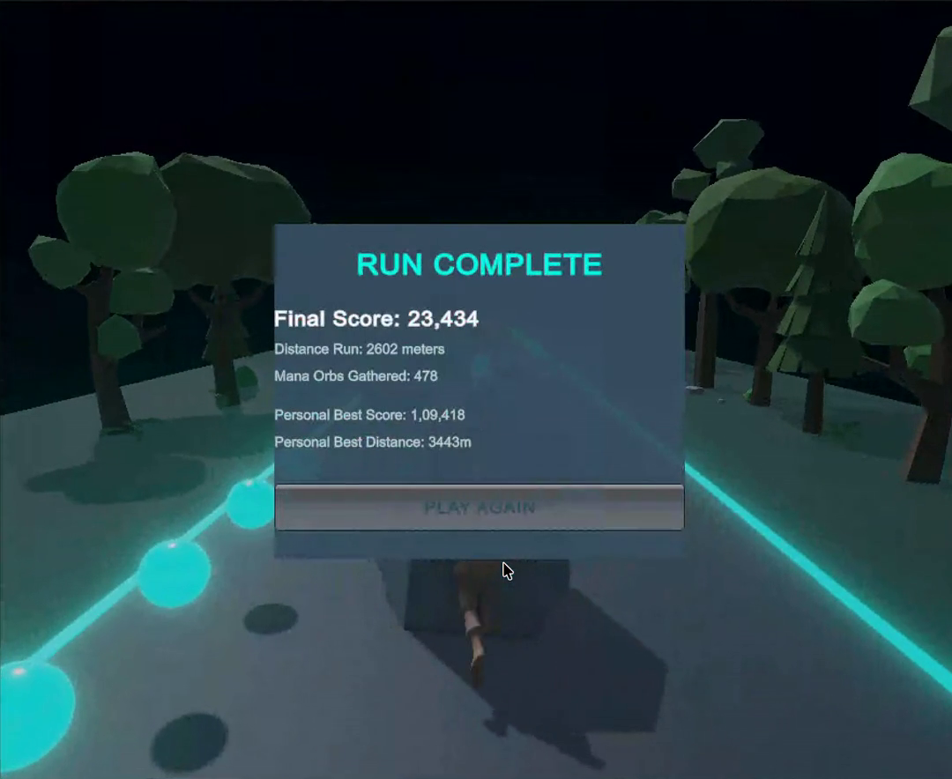
Figure 8.1: Game Over state summary overlay with PlayerPrefs high-score persistence.
Source note: Captured at 03:36. Final Score 23,434 · Distance Run 2,602 m · Mana Orbs Gathered 478 · Personal Best Score 1,09,418 · Personal Best Distance 3,443 m · PLAY AGAIN button.

